Embedded Questions MAC 2312 and MAC2282

Spring 2010

- Find the derivative:

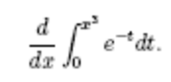

- Find the total area of the region between the graph of
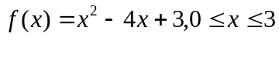

and the x-axis.

- Find the volume of the solid generated by revolving about the x-axis the region bounded by 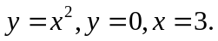

- Find the lateral surface area of the cone generated by revolving about the x-axis the line segment 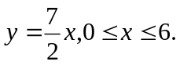

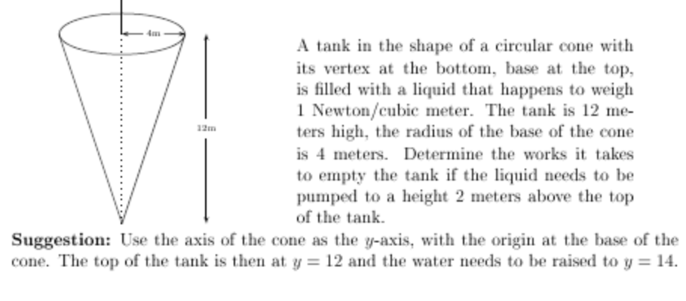

- Integrate:

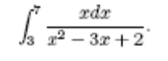

- Integrate:

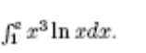

- Integrate:

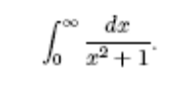

- Does the following series converge, or diverge? Give a reason?

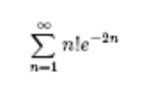

- Find the series’ radius and interval of convergence:

